

\_\_\_\_\_\_\_\_\_\_\_\_\_\_\_\_\_\_\_\_\_\_\_\_\_\_\_\_\_\_\_\_\_\_\_\_\_\_\_\_\_\_\_\_\_\_\_\_\_\_\_\_\_\_\_\_\_\_\_\_\_\_\_\_\_\_\_\_\_\_\_\_\_

**Principles of Financial Planning:**

**Asset Allocation**

© 2016 Greene Consulting Associates, LLC INTENDED SOLELY FOR USE BY REGISTERED USERS NOT TO BE REPRODUCED OR CIRCULATED

## ABOUT GREENE CONSULTING ASSOCIATES, LLC

Greene Consulting Associates was founded in 1979 and provides consulting and training services solely to the financial services marketplace. Located in Atlanta, Georgia, Greene Consulting has worked with the top providers of investment management and wealth management in both the United States and abroad. Focused on helping firms generate incremental revenue growth through more effective sales and relationship management strategies, Greene Consulting offers customized training programs in Financial Services Sales, a Sales Management program, Presentation Training that integrates proprietary products, and a comprehensive suite of online learning courses related to investments and wealth management.

For more information about Greene Consulting or any of its products and services, write Greene Consulting at Waterstone Building, 4751 Best Road, Suite 450, Atlanta, Georgia 30337. Or, visit the company's website at [www.greeneconsults.com](http://www.greeneconsults.com).

## Table of Contents

Introduction

The Primary Goal of Asset Allocation

Expected Return of Asset Classes

Rates of Return for Various Periods

Understanding Risk

Communicating the Impact of Inflation Risk

Inflation Risk and Real Rates of Return

Communicating the Impact of Market Risk

Quantifying Market Risk

Returns of the Market

Outcome Risk

Communicating the Impact of Time

Review Exercise

Does Time Really “Reduce” Risk?

The Impact of Time

Importance of a Long-Term Perspective

The Next Level – Applying Asset Allocation Theory

The Capital Asset Pricing Model (CAPM)

Beta as a Measure of a Stock’s Relative Risk

The CAPM Formula

Review Exercise

Understanding the Security Market Line

Systematic versus Unsystematic Risk

Understanding Alpha

Shortcomings of the CAPM

Review Exercise

Modern Portfolio Theory (MPT)

The Underpinnings of MPT

Inputs Required for Mean Variance Optimization

Correlation’s Impact on Portfolio Risk

Establishing an “Efficient Frontier”

The Typical Investor Situation

Monte Carlo Sensitivity Analysis

Communicating Benefits of Monte Carlo Sensitivity Analysis

Review Exercise

Strategic Asset Allocation

Tactical Asset Allocation

Comparing Strategic vs. Tactical Allocation Strategies

The Planning Process in Action

Lack of Clearly Defined Objectives

Failure to Monitor/Manage the Portfolio Over Time

Review Exercise

Conclusion

## Introduction

Asset allocation is certainly recognized as a fundamental part of investing, especially in light of the recent deflation of the “Internet Bubble.” Almost every investment professional knows the importance of asset allocation in a rational and well-thought-out investment plan, yet few understand the theoretical foundations of asset allocation strategies or have a clear understanding of how they apply in the everyday world in which they deal with clients.

|  |
| --- |
| **Objectives:**  This course will address both the theory and the real world application of asset allocation with clients. By the end of this course, you will be able to understand:   * Fundamental investment planning concepts – Return, Risk, Time * Advanced investment planning techniques – Modern Portfolio Theory, Mean Variance Optimization, Monte Carlo Analysis * The Capital Asset Pricing Model and its application in the asset allocation process * The relevance of Modern Portfolio Theory in the asset allocation process * Common asset allocation processes used in constructing portfolios |

## The Primary Goal of Asset Allocation

There is one primary goal of asset allocation within the investment planning process — **achieving the investment objective with the minimum risk**. Thus, asset allocation is the process of allocating assets in a portfolio among different asset types in order to achieve a mix that can be expected to produce the desired return for a given time horizon with the minimum risk. Given that every asset or asset class has a different risk/return profile, it follows that there are thousands of possible portfolio structures. The goal of asset allocation is to identify an optimal investment portfolio for a client’s situation.

It is also important to recognize that asset allocation takes place in the context of the client’s risk tolerance and time horizon. In general, a client’s risk tolerance helps to determine his/her asset allocation strategy and thus the targeted rate of return since higher return is generally associated with higher volatility. Likewise, the time horizon must be taken into consideration because, as we shall see, time is a significant factor in the long-term expected return of a portfolio.

Over the past 50 years, there has been much theoretical research that has influenced the evolution of asset allocation as we know it today – the Capital Asset Pricing Model, Modern Portfolio Theory, Mean Variance Optimization, and Monte Carlo Sensitivity Analysis. We will look at each of these, but in the next few pages we focus our attention on the fundamentals that undergird these theories – return, risk, and time.

## Expected Return of Asset Classes

To evaluate the return potential for the most often used investment vehicles, let's look at the total rate of return produced by stocks, bonds, and money market instruments over the last 25 years. Again, total return is the sum of growth and yield for a given investment.

The chart compares each investment vehicle with the rate of inflation that occurred during the same period.

As the chart and numbers illustrate, stocks substantially outperformed bonds during this period, bonds outperformed T-Bills or money market instruments, and all three of these instruments outpaced the rate of inflation.

**Click each graph label to learn more.**

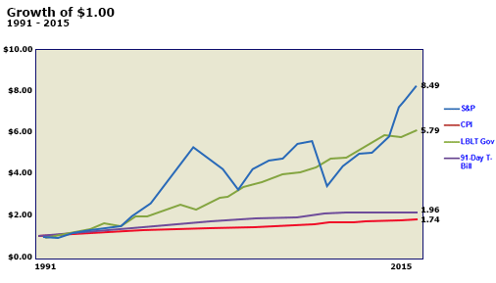

|  |
| --- |
| **S&P 500**  Stocks over the past 25 years grew at an annualized rate of 8.93% for the period of 1991-2015. If $1 had been invested at the beginning of 1991, its current value would be $8.49 |

|  |
| --- |
| **Bonds**  \*Bonds over the past 25 years grew at an annualized rate of 7.28% A dollar invested at the beginning of 1991 would now have a value of $5.79.  *\*Because of the dissolution of Lehman Brothers in 2008, the bonds measurement is a combination of both the Lehman Brothers Long-term Government/Credit Bond Index and the Barclays US Long Government/Credit Index.* |

|  |
| --- |
| **T-Bills**  T-Bills have grown at an annualized rate of 3.01% over the last 25 years and a dollar in 1991 would now have a value of $1.96. |

|  |
| --- |
| **Inflation**  As shown, inflation diminished the purchasing power of an investment at an annualized rate of 2.2%. Or stated another way, it would take $1.74 today to purchase what $1.00 would have purchased in 1991. |

## Rates of Returns for Various Periods

Over long periods of time, the comparative returns of stocks, bonds, and T-bills (money market instruments) have remained fairly consistent, with stocks having provided the highest return on investment. As the chart below shows, this relative performance has not been repeated in recent times.

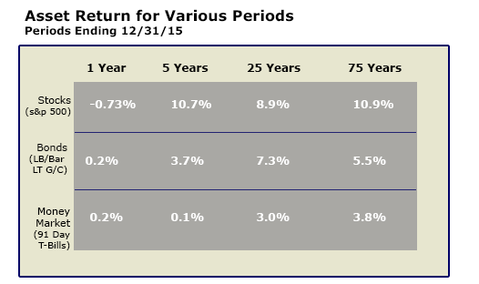

Over the past 5 years, stocks have reached rates of return slightly higher than for the past 25 years. Given this above average performance, investors must ask themselves, "Are shorter-term stock returns more reflective of future returns or will returns gravitate back to a more historic norm?"

How this question is answered may have significant impact on the investment decisions that are made.

## Understanding Risk

While most investors desire maximum return on their investment, they must consider the risk associated with each investment vehicle. Many people define risk as the amount of money that can be lost in an investment. However, that simplistic definition for risk is far too narrow and can lead to significant miscalculations in an investment plan.

Before getting into the quantitative derivations of risk, let’s first examine the three major types of risk.

**Click each type to learn more.**

|  |
| --- |
| **Inflation Risk** |
| Because the price of goods and services in the economy continue to rise, there is a constant erosion of purchasing power for each investor’s assets. If a person fails to achieve a rate of return on capital that exceeds inflation, then the person is, in fact, losing purchasing power and lowering his or her net worth. Inflation risk is defined as the exposure to loss in purchasing power because of inflation. |
| **Market Risk** |
| This is the most commonly used definition of investment risk. Most would classify this risk as the volatility in principal value of an investment over a certain period of time. Market risk also covers the potential risk of losing value in an investment because of depreciation in price. |
| **Outcome Risk** |
| This is the most often overlooked risk, yet should be the most important when developing an investment plan. Outcome risk is defined as the risk of not achieving the desired quantitative outcome of the plan and thereby falling short of meeting a need or reaching an objective. |

Most investors understand inflation and the diminishing effect it has on investment returns. Likewise, most investors understand market risk or volatility and its effect on security price. To avoid market risk, investors sometimes choose investments they believe to be "safer and more stable," such as money market securities and short-term bonds. But these “conservative” instruments historically have not produced the return needed to meet typical investment goals, like saving for retirement. Therefore, the investor, by seeking to avoid volatility or shorter-term market risk, is taking on another type of risk that often is not realized until time passes. This risk, “outcome risk,” is the risk that the results of investing will be inadequate to meet long-term goals.

In the pages that follow, each of these types of risk will be examined in more detail.

## Communicating the Impact of Inflation Risk

To fully comprehend inflation risk, it is necessary to understand what inflation is and how it affects the purchasing power of money. Inflation is the rate at which the price of goods and services increases, thereby reducing the buying power of money.

In an inflationary environment, investing is like walking up an escalator that's going down. Climbing (or investing) increases the amount of money one can have, while inflation constantly reduces the value or the purchasing power of that money.

Investors often fail to recognize the risk associated with inflation. Two paths that make them victims of inflation are:

* **Do nothing** - allowing inflation to nibble away at the value of their money.
* **Invest too conservatively** - letting inflation and taxes consume much of their investment return.

The graphic illustrates the magnitude of inflation risk.

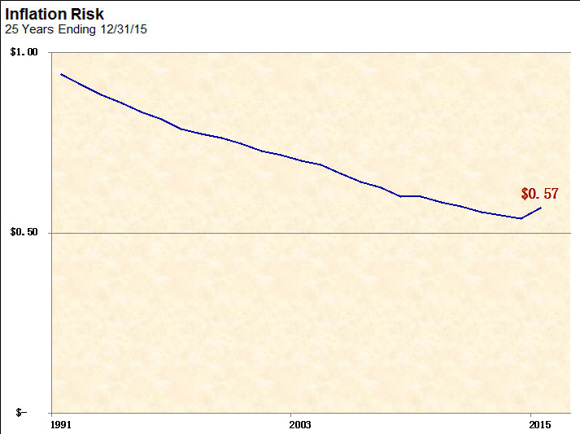

For the last 25 years ending in December 2015, the purchasing power of one dollar has declined to just fifty-seven cents. Therefore, the total return of an investment only tells part of the story; it must be measured relative to the inflation that occurred during that period of time, if the true performance is to be observed.

## Inflation Risk and Real Rates of Return

Adjusting return for the impact of inflation is known as deriving the **real rate of return**. This is calculated as follows:

**Real Return = Total Return - Inflation**

In other words, real return takes into account the deflated growth of an investment.

The graphic below shows the annualized **"nominal"** (before adjustment for inflation) rate of return for stocks, bonds, money market securities, and inflation for the last 25 years. It shows that stocks grew at a compound rate of 8.9%, bonds grew at a rate of 7.3%, and money market securities at 3.0%. But the **"real"** picture, after adjusting for inflation, is quite different.

When the eroding effect of inflation is taken into account, the real return for each asset class was reduced to 6.7%, 5.0% and 0.5% respectively. These may not reduce exactly by 2.2% due to the effect of compounding.

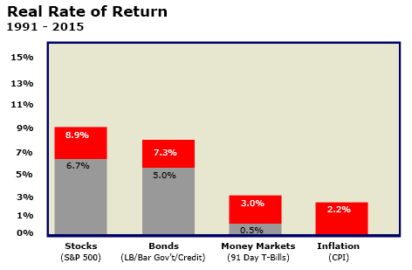

## Communicating the Impact of Market Risk

While inflation risk can deflate the value of the dollar substantially, market risk, or the fluctuating rates of return, can also affect investment returns. This is risk that is derived simply from association with the market.

Fluctuations in the overall market are generally reflected in individual portfolios. It can be observed by considering the fluctuating annual rates of return for stocks, bonds, and money market securities that occurred during the past 25 years. This is illustrated in the chart below, which shows the maximum and minimum annual returns, as well as their average, for each of these common asset classes during the past 25 years. Clearly, the potential risk associated with any given year is substantial. But the market risk is not the same for all asset classes.

**Click each bar graph title for an explanation of the returns of each Asset Class.**

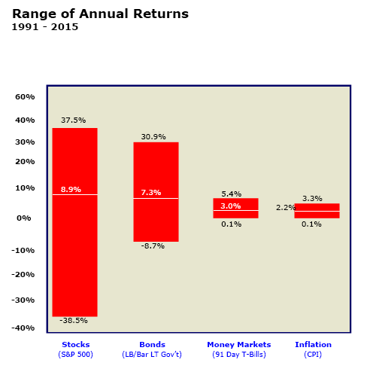

|  |
| --- |
| **Stocks (S&P 500)**  The maximum one-year return produced by stocks, as measured by S&P 500 during the 25-year period, was 37.5%, occurring in 1995. The worst one-year rate of return for the same period was in 2008 when stocks lost 38.5% of their value. The annualized rate of return for the same period was 8.9%. |

|  |
| --- |
| **Bonds (LB LT Govt./Credit)**  \*Bonds, for the same 25-year period of time, had a maximum one-year total rate of return of 30.9%, occurring in 1995. The worst one-year total rate of return for bonds was –8.7%, occurring in 1999. The annualized rate of return for the 25-year period of time for bonds was 7.3%.  *\*Because of the dissolution of Lehman Brothers in 2008, the bonds measurement is a combination of both the Lehman Brothers Long-term Government/Credit Bond Index and the Barclays US Long Government/Credit Index.* |

|  |
| --- |
| **Money Market (91-Day T-Bills)**  Money market instruments, as measured by 91-day T-Bills, produced a maximum rate of return for any one-year period during this 25-year period of 5.4%. This occurred in 1991. The minimum rate of return was 0.1%, occurring several times, but most recently in 2015. The annualized rate of return was 3.0%. |

|  |
| --- |
| **Inflation (CPI)**  Inflation over the same period had a range from 0.1% in 2008 to a maximum of 3.3% in 1996 with an annualized inflation rate of 2.2% for this 25-year period. |

## Quantifying Market Risk

In quantifying market risk, we begin to make a transition from the basics that nearly everyone understands to the more intricate aspects of asset allocation theory and its application in today’s environment. The common way to measure market risk is through an examination of the dispersion of returns over a given time period. This can be measured in standard deviations, which is a statistical measure for quantifying the dispersion of returns around the mean (average). The greater the standard deviation, the more volatile the asset is and the greater its risk.

To understand standard deviation and its application in the measurement of market risk, look at the following chart. It represents what is referred to as a normal distribution of events. When a series of events follow a normal distribution, we can begin to predict the future events within a given probability.

**Click each of the arrows to learn more.**

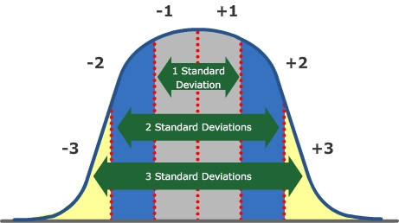

|  |
| --- |
| **Gray**  Approximately 68% of all events will fall within (+/-) one standard deviation from the Mean |

|  |
| --- |
| **Blue and Gray Sections Combined**  Approximately 95% of all events will fall within (+/-) two standard deviations from the Mean. |

|  |
| --- |
| **Yellow, Blue, and Gray Sections and Combined**  Approximately 99% of all events will fall within (+/-) three standard deviations from the Mean |

## Returns of the Market

Is there a pattern for returns on the market that tells us what we can expect in the future?

This chart provides an interesting picture into the distribution of annual returns for the equity market.

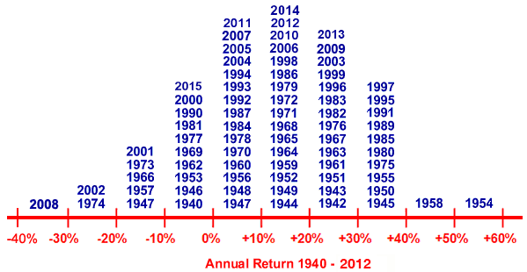

It is readily evident that the stock market returns follow a normal distribution around the mean. **Click here to view an example.**

|  |
| --- |
| **Example**  If the average annual return on the S&P 500 for this time period was 11.5% with a standard deviation of 7%, we could expect that 68% of the time, the annual return of the index would be between 4.5% (i.e., 11.5% - 7%) and 18.5% (i.e., 11.5% + 7%). Going out one more standard deviation, 95% of the time the return would be between -2.5% and 25.5%. This pattern is very important, as it allows for the quantification of risk in terms of asset class volatility and provides the fundamental framework for asset allocation approaches that seek to diversify away risks without compromising returns. |

## Outcome Risk

The third type of risk, outcome risk, is often overlooked. But it is probably the most important risk for investors to consider.

Outcome risk is the risk that the final outcome of the investment plan will fail to meet an obligation or to achieve a desired result over a specified time. If the expected return of a portfolio is below the desired outcome, then the shortfall is a measure of the outcome risk. For example, if the expected return of an investment for a child's education fails to provide enough money when it is needed, then the portfolio has significant outcome risk.

Investors normally tend to focus on short-term risk or market risk and often overlook outcome risk because it is “in the future”. But it must always be kept in mind because it is the reason why it has historically been necessary to accept some amount of short-term volatility. Failure to accept some short-term risk might mean never attaining one’s long-term goals.

## Communicating the Impact of Time

A final issue related to asset allocation is time horizon for the investor related to the goal. While there are typically multiple goals, each with their own time horizon, this issue becomes very important as longer time periods typically make greater short-term risk more tolerable.

The impact of time can be illustrated by breaking the past 25 years into different time periods. If each year is taken as an independent time period, the range of returns from year to year is very wide, with the potential for very significant losses in any given year. But when the past 25 years are broken into time periods of 5 years each, the range narrows considerably.

Break it into 10 and 20-year periods, and the range narrows further, with neither offering a time when the return was negative. This data confirms that for longer holding periods, the probability of negative returns decreases, and the gap between the maximum and minimum total return is reduced.

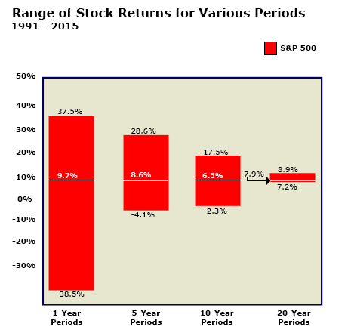

## Review Exercise – Answer Key

**Review the previous pages by answering the following questions.**

1. **Asset allocation attempts to diversify away risk without compromising returns.**

* **True**

**Correct.**

* False

**Incorrect.**

1. **\_\_\_\_\_\_\_\_\_\_ slightly outperformed \_\_\_\_\_\_\_\_\_\_ over the last 25 years**

* Bonds, stocks

**Incorrect.**

* **Stocks, bonds**

**Correct!**

* T-Bills, bonds

**Incorrect.**

* T-Bills, stocks

**Incorrect.**

1. **Which risk involves the volatility in principal value of an investment over a period of time?**

* Inflation Risk

**Incorrect.**

* **Market Risk**

**Correct.**

* Principal Risk

**Incorrect.**

* Outcome Risk

**Incorrect.**

1. **Real Return is equal to nominal return.**

* True

**Incorrect**

* **False**

**Correct.**

1. **In quantifying market risk, what percentage of returns will fall within one standard deviation of the mean?**

* 15%

**Incorrect.**

* 33%

**Incorrect.**

* 50%

**Incorrect.**

* **68%**

**Correct.**

* 95%

**Incorrect.**

## Does Time Really “Reduce” Risk?

The use of “time” as a risk reduction tool requires a note of caution. While the long-term averages for the market are fairly constant, the volatility of returns within moderate time frames can cause an investor difficulty in achieving “the average return.” Few investors will consistently experience “the average return.” Volatility will always have an impact, particularly when taking into consideration differences in economic cycles.

In other words, ***timing*** (when one enters the market and when one leaves) can be very important, as illustrated in the following exercise.

|  |  |
| --- | --- |
| **Overview** | For each time period, compare the actual return that would have resulted with the same asset allocation. **Select each of the three historical 5-year time periods on the left.** |
| **1970 - 1974** | |  |  |  | | --- | --- | --- | | $100,000  Initial  Investment | 55% U.S. Stocks (S&P 500) | $48,736 | | 20% U.S. Bonds (Govt. Long Term) | $28,448 | | 10% Money Market | $13,340 | | 15% International Stocks | $13,401 | |  | Total | **$103,925** | |
| **1983 - 1987** | |  |  |  | | --- | --- | --- | | $100,000  Initial  Investment | 55% U.S. Stocks (S&P 500) | $117,618 | | 20% U.S. Bonds (Govt. Long Term) | $37,288 | | 10% Money Market | $14,350 | | 15% International Stocks | $59,865 | |  | Total | **$229,121** | |
| **1994 - 1998** | |  |  |  | | --- | --- | --- | | $100,000  Initial  Investment | 55% U.S. Stocks (S&P 500) | $161,695 | | 20% U.S. Bonds (Govt. Long Term) | $31,270 | | 10% Money Market | $12,726 | | 15% International Stocks | $21,575 | |  | Total | $**227,266** | |

## The Impact of Time

While time may not eliminate risk in the form of volatility, it is vital in increasing the impact of returns through compounding. As the following scenarios demonstrate, the length of time a portfolio has to compound can be much more important than the actual amount of an investment. **Click each scenario heading to learn more.**



|  |
| --- |
| **Scenario A**  Assume that an investor invested $1000 in an IRA at the end of every year from age 25 to 45 at 12%. At the end of 20 years at age 45, the investor made no contributions or withdrawals.  What would be the value of the portfolio at age 65? |

|  |
| --- |
| **Scenario B**  Assume that an investor invested no money from ages 25 to 45, yet began making $1000 contributions in an IRA at the end of each year for 20 years from the age of 45 to 65.  What would be the value of the portfolio at age 65? |

See below to learn about the differences between these scenarios

|  |  |
| --- | --- |
| |  | | --- | | In each scenario the amount of money invested and the time period of investment are the same ($20,000 and 20 years). **The only difference is the timing of the investment.** As shown, the additional 20 years of compounding in “Scenario A” led to significantly higher returns.  In summary, the value of time and compounding was best summarized by Albert Einstein, who said, "Compounding is mankind's greatest invention because it allows for the reliable, systematic accumulation of wealth | |

## Importance of a Long-term Perspective

Taking a final look at the impact of time, the following chart depicts the percentage of times an asset class was the top performer in various time periods.

Observe that stocks outperformed bonds and money market instruments in 57% of the one-year periods. With longer periods, stocks outperformed other asset classes more frequently. ***For time periods of 25 years, there is only one instance of stocks being outperformed, and that was the 25 year period ending in 2008.***

From these historical patterns, it is self-evident that the longer the time horizon of the investor, the greater the percentage of stocks a portfolio should contain.

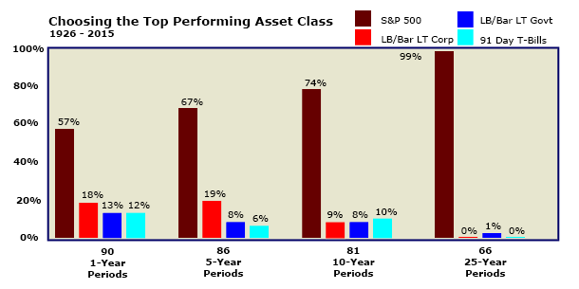

## The Next Level – Applying Asset Allocation Theory

Having looked at the fundamentals, we shall now examine how investment advisors can help clients pursue their investment goals while minimizing portfolio volatility.

This is obviously accomplished by diversifying portfolios across each of the asset classes, which requires some understanding of the historical return and risk associated with each asset class. This understanding is largely acquired by studying commonly used indices.

The advisor needs a process by which to identify the optimal allocation. There are really two approaches to this. One involves generating the highest return for any level of risk, while another involves maximizing return for a given level of acceptable risk.

To determine either one requires the use of statistical analysis and applications that have grown out of the Capital Asset Pricing Model (CAPM), which is discussed on the next page.

**Click each investment or index for more information.**

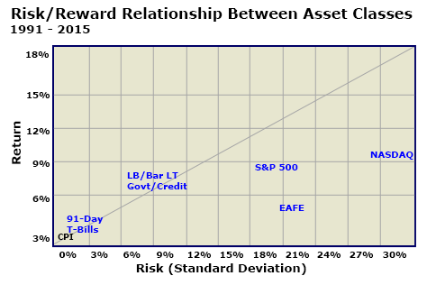

|  |
| --- |
| **91-Day T-Bills**  91-Day T-Bills had an annualized return of 3.0% and a standard deviation of 2.1% over the 25-year period from 1991 to 2015. This risk-return relationship is fairly consistent with that of the Consumer Price Index (or CPI). The CPI indicates the rate of inflation |

|  |
| --- |
| **LB/Bar LT Govt /Credit**  Lehman Brothers Barclays Long Term Government/Credit Bond Index had a return of 7.3% and a standard deviation of 8.6%. |

|  |
| --- |
| **S&P 500**  The S&P 500 had an annualized rate of return of approximately 8.9% and a standard deviation of 18.2%. |

|  |
| --- |
| **EAFE**  The index representing a broadly diversified international portfolio, EAFE (Europe, Australasia and the Far East) had an annualized rate of return of 3.7% and a standard deviation of 20.1%. |

|  |
| --- |
| **NASDAQ**  Over-the-counter stocks as measured by the NASDAQ index had an annualized rate of return and standard deviation of 10.9% and 29.6% respectively |

## The Capital Asset Pricing Model (CAPM)

The Capital Asset Pricing Model (CAPM) is the primary theory behind a number of current asset allocation practices. Therefore, an understanding of the CAPM is essential to understanding those practices.

The CAPM describes the relationship between risk and expected return, and it serves as a model for the pricing of risky securities.

|  |
| --- |
| **Simply stated, the CAPM states that the expected return of a security or a portfolio equals the rate of return on a risk-free security (like T-Bills) plus a risk premium** |

In other words, for investors to assume the incremental risk of holding the stock, they demand a premium rate of return beyond the risk-free rate. The greater the risk they must assume, then the greater the premium demanded.

The CAPM examines this risk premium of a stock relative to the risk premium of the stock market as a whole, for which the S&P 500 generally acts as a proxy. If a stock is riskier than the market as a whole, then its risk premium must be greater than that for the market for investors to purchase it. If it is less risky than the market as a whole, then its risk premium will be less than that of the market.

But how do you measure the risk of a stock relative to the market?

## Beta as a Measure of a Stock’s Relative Risk

Earlier, we stated that risk is generally measured by looking at the variation in a security’s rate of return, measured in standard deviations. But measuring the variation of a security’s rate of return is of limited use unless it is done in comparison to a benchmark. For example, let’s assume for the moment that a security’s return is only tied to changes in its price. Wide swings in a stock’s price that are perfectly in sync with a volatile market might indicate that the stock is no riskier than the market as a whole, while wide price swings on a stock’s price during a stable market might indicate that the stock is significantly riskier than the market as a whole. This movement of a stock’s return relative to the movement of the market can be statistically measured and is called ***covariance****.* Stated differently, ***covariance measures the extent of mutual variation between any two variables****.*

The CAPM uses a concept known as ***beta (ß)*** to measure the covariance between a stock and the market. In other words, ***beta (ß)*** is a measure of how a stock moves relative to movements in the market. If the beta of each stock in a portfolio is known, then the beta of a portfolio can be easily determined by calculating a weighted average of the betas of all the stocks in the portfolio. In this manner, beta can be used to speak of the risk of a stock or a portfolio relative to the market.

A high beta means that the stock is riskier than the market as a whole; a low beta means it is less risky than the market. If a security moves perfectly in sync with market movements (in the same direction and to the same degree), then it has a beta coefficient of 1.0.

For an understanding of other beta coefficients, **click each coefficient below.**



|  |
| --- |
| **0.5**  Beta coefficients below 1.0 indicate that the stock or portfolio is less risky than the market as a whole. Thus, the risk premium is less than that of the market. When the market rises, the stock (portfolio) will not be expected to rise as much; when the market declines, the stock (portfolio) will be expected to decline to a lesser degree.  **Example:** If the risk premium (the rate above the risk-free rate) for the market is 8%, a stock with a beta of 0.5 would have a risk premium of 0.5 x 8% = 4%. |

|  |
| --- |
| **1.0**  A stock with a beta coefficient of 1.0 has the same coefficient as the market as a whole, thus it is expected to behave perfectly in sync with the market. Thus, its risk premium is equal to that of the market |

|  |
| --- |
| **1.5**  Beta coefficients above 1.0 indicate that the stock or portfolio is more risky than the market as a whole. Thus, its risk premium is greater than that of the market. When the market rises, the stock (portfolio) will be expected to rise even more; when the market declines, the stock (portfolio) will be expected to decline even further  **Example:** If the risk premium (the rate above the risk-free rate) for the market is 8%, a stock with a beta of 1.5 would have a risk premium of 1.5 x 8% = 12%. |

## The CAPM Formula

The CAPM can be stated in terms of a formula for a given asset and states that **the expected rate of return for an investment asset is equal to the risk-free rate plus the risk premium of the investment**. Multiplying the beta of the investment asset by the risk premium of the market derives the risk premium of the investment asset. When dealing with a portfolio of stocks, this same formula works for the entire portfolio by calculating the weighted average of the betas of each stock in the portfolio.

**Click each formula element on the left to learn more.**

|  |  |
| --- | --- |
| **Overview** | CAPM formula states:  *E(ri )*    =    *rf*    +    *ßi*     X    *[E(rm ) - rf ]* |
| **E(ri )** | **E(ri )**  stands for the "expected return of an investment asset." |
| **rf** | **rf**  is the "risk-free rate of return." |
| **ßi** | **ßi**  is the "beta of the investment." It measures the extent of mutual variation between the investment asset and the market. |
| **[E(rm ) - rf ]** | **[E(rm ) - rf ]**  is the risk premium of the market over the risk-free rate. It is derived by starting with the expected rate of return for the market, then subtracting the risk-free rate of return, to leave only the risk premium that is in excess of the risk-free rate. |

## Review Exercise

**Answer the following questions to review the preceding material.**

1. **\_\_\_\_\_\_\_\_\_\_ describes the relationship between risk and return.**

* **CAPM**

**Correct.**

* Beta

**Incorrect.**

* Coefficient

**Incorrect.**

* Covariance

**Incorrect.**

1. **The Capital Asset Pricing Model states that the expected return of a security or portfolio equals:**

* The tax-free rate plus a risk premium

**Incorrect.**

* The risk-free rate plus a premium for the time value of money

**Incorrect.**

* **The risk-free rate plus a risk premium**

**Correct.**

* The market rate plus a risk premium

**Incorrect.**

1. **The Capital Asset Pricing Model assumes the market is:**

* **Efficient**

**Correct.**

* Inefficient

**Incorrect.**

* Stable

**Incorrect.**

* Best understood through fundamental analysis of securities

**Incorrect.**

1. **A beta \_\_\_\_\_\_\_\_\_\_ than 1.0 implies the stock is \_\_\_\_\_\_\_\_\_\_ than the market; a beta \_\_\_\_\_\_\_\_\_\_ than one implies the stock is \_\_\_\_\_\_\_\_\_\_ than the market.**

* Less, riskier; greater, less risky

**Incorrect.**

* **Less, less risky; greater, riskier**

**Correct.**

## Understanding the Security Market Line

The key message of the CAPM is that there is a direct relationship between risk and return. The implication for purposes of asset allocation is to emphasize the importance of first determining the risk tolerance of the investor, then identifying a portfolio that efficiently achieves a fair return for that given level of risk. Investors should not expect to “beat the market” unless they intend to have a portfolio that is riskier than the market as a whole.

The message and implications for the CAPM becomes more easily understood through a graph.

**Click each term on the graph for an explanation, paying particular attention to the Security Market Line**

### Security Market Line Graph

*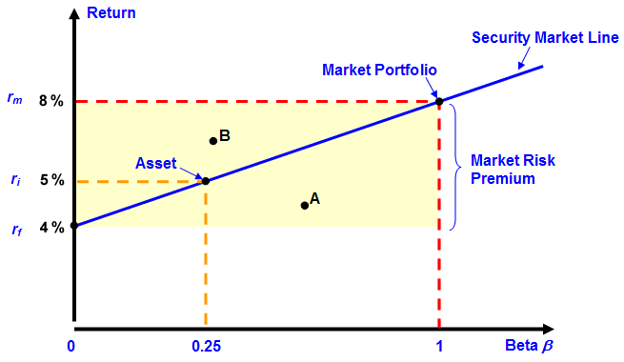*

|  |
| --- |
| **Return**  The vertical axis measures the expected rate of return of a stock or portfolio |

|  |
| --- |
| **rm**  The market return (*rm* ) is the return expected on the general market. In this illustration, it is 8%. |

|  |
| --- |
| **ri**  The rate of return for an investment asset is designated as ri. In this example, ri = 5%. |

|  |
| --- |
| **rf**  The risk-free rate (*rf* ) is the rate of return that would be expected on risk-free securities, such as T-bills. In this illustration, it is 4%. |

|  |
| --- |
| **0**  When there is no risk associated with the security or portfolio, the beta (*ß*) is zero. The CAPM teaches us that to get greater return, you must assume risk |

|  |
| --- |
| **0.25**  When a stock or portfolio has some risk, but less risk than that of the general market, its beta (*ß*) is somewhere between 0 and 1. For this asset, the beta is 0.25. Using the CAPM formula, its expected return is therefore:  *E(ri ) = rf + ßi x [E(rm ) - rf ]*  *E(ri ) = 4% + 0.25 x (8% - 4%) = 5%* |

|  |
| --- |
| **Asset**  This example looks at a single investment asset. It could just as easily look at a portfolio of stocks by calculating a weighted average of their betas |

|  |
| --- |
| **1**  The beta of the general market is 1. To gain a higher expected return than the general market, an investor must assume more risk than the general market. |

|  |
| --- |
| **Beta ß**  The horizontal axis measures the risk associated with the stock or portfolio as beta (*ß*). This risk is determined relative to the risk of the market as a whole |

|  |
| --- |
| **Market Risk Premium**  The risk premium required by investors for holding an S&P 500 Index fund rather than risk-free securities is the incremental return over and above the risk-free rate of return. This is depicted here by spread between the risk-free return of 4% and the market return of 8%. |

|  |
| --- |
| **Market Portfolio**  The Market Portfolio, for which the S&P 500 can serve as a proxy, has a beta of 1. In this case, the rate of return for the market portfolio is 8%. |

|  |
| --- |
| **Security Market Line**  Connecting the risk-free asset and the market portfolio with a straight line depicts the "Security Market Line." This straight line reflects the fact that the expected risk premium on all possible stocks or portfolios varies in direct proportion to their beta. Under the premise of the CAPM theory, all efficient portfolios (combinations of various securities) lie on this security market line. Thus, for any given level of risk, an investor can use the Security Market Line to identify the return he should expect from a portfolio by checking the corresponding value on the y-axis.  For example, look at the asset labeled "A." It offers a rate of return lower than would be expected for an asset of comparable risk on the security market line. Investors will bid its price down until its rate of return moves it up to the security market line. Likewise, asset "B" offers a higher return than an asset of comparable risk on the security market line. Investors will bid its price up until its return declines to the security market line. Based on the belief that the market is very efficient in processing information and making such adjustments, the CAPM contends that these adjustments take place very quickly. |

## Systematic versus Unsystematic Risk

The CAPM is based on the assumption that all stocks share a common risk by virtue of their association with the market. For example, when the Fed dramatically raises interest rates, there is generally a negative impact on the stock market. An individual stock will generally suffer a decline in price just because of its association with the market. This risk, which stems from association with the market, is called ***systematic risk***. When the general market moves, it has a “systematic” effect on all securities in the market.

But there is also risk that is specific to a single security. This risk is referred to as ***specific*** or ***unsystematic risk*.**

In the CAPM, the beta of a stock reflects only its sensitivity to market movements (systematic risk). It does not reflect unsystematic risk. Since diversification with multiple stocks can eliminate specific risk through balancing out the vagaries of one stock with the vagaries of others, the CAPM works under the premise that capital markets do not yield a premium for risks that an investor can eliminate through diversification.

## Understanding Alpha

The fact is that while the CAPM ignores performance variations outside expected returns, such variations do in fact exist. And while the efficient market theory dictates that portfolio managers cannot achieve “excess” return, history has shown that, for given periods of time, some in fact do achieve excess return, while others underperform.

A key term used in asset allocation to account for the impact of the portfolio manager on performance is ***alpha (a)***. This term, whose basis is in CAPM theory, can be especially helpful as you seek to allocate investments among different money managers to achieve diversification.

**Alpha compares the expected return of a stock or portfolio (based on its beta) to its actual return.** If a portfolio’s actual return over time is greater than expected, then this is deemed “excess return.” The question to be answered is: “What is the cause of this excess return?“ For example, is it caused by a corresponding excess return in the market? If so, then the CAPM works to fully explain the situation. Or is this excess caused by an independent factor, such as the skill of the portfolio manager?

To answer this question, the chart below samples the return of a portfolio over time and plots the portfolio’s excess return against the excess return of the market for the same time period. After taking the samples, regression analysis is used to plot a line through the samples that represents the average of the scattered plots. If the CAPM holds, the portfolio should have zero excess return when the market has zero excess return and the line should intercept the axis at zero. When that doesn’t happen, another factor has been introduced, which either caused excess return (causing the line to intercept above the horizontal axis) or it caused diminished return (causing the line to intercept below the horizontal axis). ***Alpha is the magnitude of the distance from the horizontal axis to the point where the line intercepts the vertical axis****.* Generally speaking, alpha is used as a measure of the portfolio manager’s contribution to the performance of the portfolio.

**Click each term below to learn more**

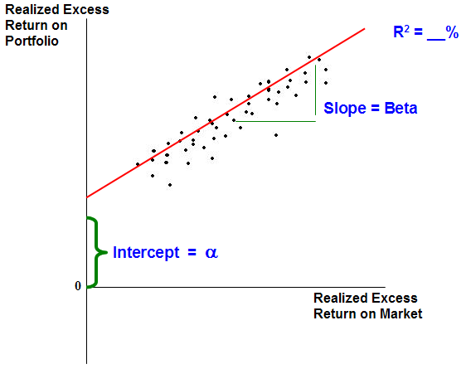

|  |
| --- |
| **Alpha**  Alpha identifies the difference in expected return of a portfolio, based on the beta of the portfolio, versus the actual returns that were achieved. The higher your alpha, the better your portfolio has done in achieving “excess returns. It is generally considered to be a measure of the “value added” by the portfolio manager. The higher the alpha, the higher the “value added” by the portfolio manager, while a negative alpha indicates that the portfolio manager’s efforts were counterproductive, resulting in diminished returns.  **Note:** The market portfolio alpha is always zero. |

|  |
| --- |
| **Beta**  Beta measures the portfolio’s sensitivity to movements in a benchmark index, such as the S&P 500. A beta greater than 1.0 means that the security or portfolio is more volatile than the benchmark index, and a beta less than 1.0 means the asset or portfolio is less volatile. |

|  |
| --- |
| **R2**  This is a strictly "statistical term" that indicates the percentage of a portfolio's movement that is explained by the movement in the benchmark index. R2 ranges from 0 to 100%, with a score of 100% indicating that all movements of the portfolio are completely explained by the benchmark index. In general, the higher the R2, the more reliable a portfolio's alpha and beta measurements will be. |

## Shortcomings of the CAPM

While the Capital Asset Pricing Model was revolutionary at the time, there are several reasons to question its efficacy in today’s market context.

**Click each reason to learn more.**

|  |
| --- |
| **Limited to Equities** |
| The CAPM only addresses equities. It does not really address the issues of multiple asset classes. |
| **Assumes an Efficient Market** |
| The CAPM assumes the market is perfectly efficient and that all information regarding a stock is quickly processed by the market and reflected in the price of the stock. Efficient market theories contend that underlying research on a stock is not necessary; the price is all you need to know. But very few investment managers or investors actually behave in that manner. |
| **Ignores the Underlying Company** |
| As an outgrowth of its commitment to an efficient market, the CAPM has nothing to say about individual companies. It is totally built upon calculations using historical data on the market and stock prices. One company might manufacture computers while another manufactures pencils, but the CAPM views them the same if they have the same beta. |
| **Assumes the Future is Like the Past** |
| The CAPM is built off of historical numbers, and assumes the future will reflect the past. While the future does “imitate” the past, the correlation between the two is quite imperfect. |

## Review Exercise

**Review the following scenario and chart and answer the following questions.**

An investor comes to you with the following data regarding his portfolio and asks you to provide your assessment and commentary on the following issues.

|  |  |  |
| --- | --- | --- |
| **Market Exposure Measurement** | **Portfolio** | **S&P 500 Index** |
| Beta | 1.4 | 1.0 |
| Alpha | 7.2 | 0 |
| R2 | 77% | 100% |

1. **The prospect wants to know your assessment of the risk profile of the portfolio. Based on the table above, your assessment is that the portfolio’s risk profile is:**

* Lower than the market

**Incorrect.** Remember under the CAPM framework, beta is used as a measure of relative volatility. Because the beta of the portfolio is 1.4, the portfolio shows volatility greater than the S&P 500.

* Same as the market

**Incorrect.** Remember under the CAPM framework, beta is used as a measure of relative volatility. Because the beta of the portfolio is 1.4, the portfolio shows volatility greater than the S&P 500.

* **Higher than the market**

**Correct.** Because the beta of the portfolio is 1.4, the portfolio shows volatility greater than the S&P 500.

* Cannot make a rational assessment

**Incorrect.** Remember under the CAPM framework, beta is used as a measure of relative volatility. Because the beta of the portfolio is 1.4, the portfolio shows volatility greater than the S&P 500.

1. **The prospect also would like your opinion on the effectiveness of this portfolio to generate “value added.” Based on nothing more than the information in the table above, what can you tell the prospect?**

* The portfolio is too risky and is not generating value.

**Incorrect.** Remember that alpha is an important statistic providing information on the portfolio's returns relative to the expected returns based on general exposure to systematic (index related) risks. Try again.

* **The portfolio has shown performance results above what would be expected based on the risk profile relative to the S&P.**

**Correct.** A positive alpha value indicates that the portfolio has delivered returns above what would be expected based on the portfolio's exposure to systematic risk (index related exposure).

* The portfolio is poorly structured/managed as indicated by the r2 of 77%.

**Incorrect**. Remember that alpha is an important statistic providing information on the portfolio's returns relative to the expected returns based on general exposure to systematic (index related) risks. Try again.

* It is impossible to tell without looking at the portfolio holdings.

**Incorrect**. Remember that alpha is an important statistic providing information on the portfolio's returns relative to the expected returns based on general exposure to systematic (index related) risks. Try again.

1. **What does an r2 of 77% indicate to you?**

* Given the limited amount of data you have, the r2 here does not have any real relevance

**Incorrect.** Remember that r2 is a statistical measure that provides insight into the confidence level you can have regarding the accuracy of the regression results. Try again.

* R2 of 77% shows that the portfolio is not effectively diversified.

**Incorrect**. Remember that r2 is a statistical measure that provides insight into the confidence level you can have regarding the accuracy of the regression results. Try again.

* The r2 provides a low level of confidence in the alpha and beta figures.

**Incorrect**. Remember that r2 is a statistical measure that provides insight into the confidence level you can have regarding the accuracy of the regression results. Try again.

* **You can have reasonable confidence that the quantified alpha and beta listed are accurate reflections of the portfolio characteristics.**

**Correct.** The r2 of 77% provides a reasonable, albeit not definitive, level of confidence that the listed portfolio characteristics are accurate.

1. **The risk associated with this portfolio that is completely independent of its participation in the overall stock market is called:**

* Systematic Risk

**Incorrect**. Systematic Risk is the risk that is in common with that of the market. Try again.

* B. Unsystematic Risk

**Incorrect**. While the risk that is unique to an asset or portfolio is called Unsystematic Risk, it also goes by another name. Try again.

* C. Specific Risk

**Incorrect.** While the risk that is unique to an asset or portfolio is called Specific Risk, it also goes by another name. Try again.

* D. Both A. and C.

**Incorrect.** Systematic Risk is the risk that is in common with that of the market. Try again.

* **E. Both B. and C.**

**Correct.** The risk that is unique to an asset or portfolio is called Unsystematic Risk or Specific Risk.

## Modern Portfolio Theory (MPT)

In actual practice, beta is not the most effective measure of risk in investing. Nor is it very intuitive. There had to be a better, more robust way to model risk and portfolio returns. Harry Markowitz accepted that challenge in his approach called “Modern Portfolio Theory.”

Markowitz used mathematics to establish an approach for modeling efficient investment portfolios using multiple securities. His seminal work was titled “Portfolio Selection” and focused on ***how to allocate assets among various alternatives to achieve the highest level of return for any level of risk incurred.***

Whereas the CAPM defined risk of a stock by its relationship to the market (ß), Markowitz’ Modern Portfolio Theory (MPT) uses standard deviation in measuring the risk of a stock or portfolio. Standard deviation measures the variability of returns, or unpredictability of returns, irrespective of association to the general market. In actual practice, this probably displays a truer picture of how investors view their investments. After all, they are generally more concerned with the overall variability of the return on their stock or portfolio than they are with its sensitivity to market movements.

While initially designed to address allocation of assets among various common stocks, the thesis has been extended to address asset allocation in the traditional context where investors are attempting to determine ***the most efficient mix of various asset classes*,** not just various stocks. Thus, Modern Portfolio Theory has greater relevance to the subject of asset allocation.

## The Underpinnings of MPT

Markowitz based his logic on the underlying thesis that all investors avoid risk whenever possible. Being risk-averse, they must be paid a premium for taking risk. The objective of Modern Portfolio Theory is to identify the most effective risk-return profile, given the securities available to an investor.

The approach used to accomplish this goal is referred to as “Mean Variance Optimization”.

|  |  |
| --- | --- |
| **Overview** | While it sounds imposing, it makes fundamental sense when you break it down into the following statement. **Click each term to learn more.** |
| **Mean** | The average expected return of all securities under consideration is the ***mean.*** |
| **Variance** | The variance of each security around the average return ***(the mean variance)*** is a measure of the risk associated with the security. The same is true for any combination of securities. The greater the variance from the mean, the greater the risk. |
| **Optimization** | For any given level of risk the investor is willing to assume (the acceptable level of mean variance), the goal is to find the optimum mix of assets that will give the greatest return for that level of risk. |

## Inputs Required for Mean Variance Optimization

Three inputs are required to discern the Mean Variance Optimization (MVO) for any group of securities.

1. Expected returns for each asset
2. Return volatility (or standard deviation) of each asset
3. Correlation coefficient for every pair of assets in the portfolio

The third input, “correlation coefficient,” needs some explanation. Correlation is defined as the degree to which two asset classes or investments will have similar returns (or act the same) under a specific set of market or economic conditions. Stated differently, it is a measure of how much the return of two investments “co-relate” to each other.

Typically, investments with “like” make-ups and “like” results have high correlation. Likewise, investments with “unlike” make-ups and “unlike” results have low correlation. This is illustrated in the following diagram, which shows how two indices correlate to the Dow Jones Industrial Average.

**Click the underlined indices for an explanation of how they correlate to the Dow Jones Industrial Average**

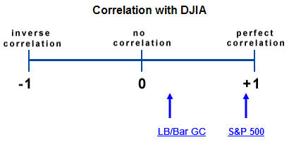

|  |
| --- |
| **LB/Bar GC**  Conversely, the DJIA and LB/Bar GC (Lehman Brothers/Barclays Government/Credit bond index), have historically had a lower correlation because stocks and bonds have historically reacted differently to economic conditions. |

|  |
| --- |
| **S&P 500**  The returns achieved by the Standard & Poor's 500 (S&P 500) and the Dow Jones Industrial Average (DJIA) have historically had a high correlation to each other. That is, when the Dow has increased 1 percent, in general, the S&P 500 has historically increased at a similar rate.  These two indices are slightly different in that the Dow Jones Industrial Average contains 30 stocks each with a large capitalization and the S&P 500 has 500 stocks. So one is substantially larger than the other, but they are both representative of highly capitalized corporations and therefore have had a relatively high degree of correlation to other. |

## Correlation’s Impact on Portfolio Risk

|  |
| --- |
| While such perfect inverse correlation is certainly extreme, this example helps illustrate how the correlation between two securities can have a significant impact upon their combined return, as well as the overall risk of the portfolio.  Effective diversification should lower portfolio volatility. In other words, the benefit of diversification is that when one asset underperforms, another can compensate. Since assets with a high correlation tend to act in the same manner in response to external stimuli, a portfolio of highly correlated securities does little to diversify risk because assets with high correlation tend to act in the same manner in response to external stimuli. Therefore, ***to effectively diversify risk (lower volatility in a portfolio), the assets, or asset classes, must have a LOW degree of correlation.***  Knowledge of how different asset classes correlate to each other is therefore a valuable aid in structuring a portfolio. To see how different indices correlate with each other, look at the chart below: |
| **MVO Example**  The importance of inputting the correlation coefficient for every pair of assets when determining the MVO of a portfolio is illustrated in the following example.   |  |  | | --- | --- | | DocumentationIcon_32px | **Click the icon to view an example.** | | Suppose two stocks, ABC and XYZ, have the same expected return and the same degree of volatility. A portfolio consisting of 1000 shares of each stock might be expected to have the same return as a portfolio consisting of 2000 shares of only one of the stocks. But what would happen if both securities were perfectly inversely correlated. If one stock increases in value by $1.00, then the other decreases in value by $1.00. The end result is no return for the portfolio because of the correlation between the two securities.  Note also that the risk or volatility associated with the portfolio is also affected. In fact, under such perfect inverse correlation, risk has essentially been eliminated. Each security has cancelled out the risk associated with the other and we are left with the certainty that the return will always be zero. | | | | |

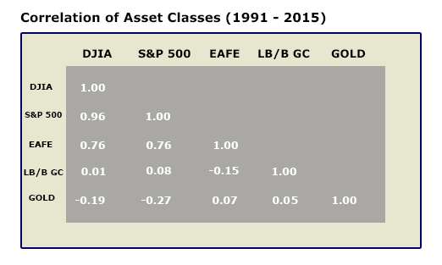

## Establishing an “Efficient Frontier”

With MVO, we can input expected return, standard deviation, and correlation of multiple assets (asset classes) and examine the possible risk return profiles of various allocations among those assets (asset classes). Since the possible combinations are extensive, the outcome is best captured graphically. The diagram below shows the risk profiles of various combinations of assets by plotting their risk (as measured by standard deviation) on the X-axis and expected return on the Y-axis:

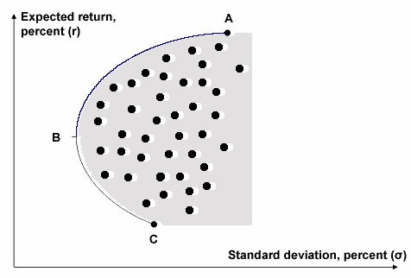

As we increase the number of plotted points for various risk profiles, we will eventually end up with a border, which is depicted by the line AC. The boomerang effect of this line, causing the border to curve back at BC, is the result of the correlation between securities, which we discussed earlier.

Clearly, any rational investor would seek to maximize the returns provided from any given level of risk. This would be found along the line depicted by AB. Any asset allocation falling on this line from A to B, known as the ***Efficient Frontier***, would be the most efficient combination possible for any given level of risk. Investors would prefer to avoid profiles that fall inside the curve, as those combinations represent a lesser return for any given level of risk. They would also avoid those profiles falling on the line depicted by BC, since these are the most inefficient profiles available for a given level of risk.

## The Typical Investor Situation

Given the background in investment theory and the models that have led to today’s approach to asset allocation and mean variance optimization, let’s look at the practical application in today’s investment planning process with your clients.

In most cases, an investor will come to you with an array of current investment holdings. Your role is to identify the risk return profile of the current holdings and model a more effective or efficient alternative. While it sounds simplistic, this can be very complicated in actual practice. This is mainly due to some of the limitations of Mean Variance Optimization.

**Click each issue to learn more.**

|  |
| --- |
| **Issue #1** |
| For Mean Variance Optimization to give correct results requires that all the inputs are correct, meaning the expected returns, correlations and standard deviations are right for each asset class. If any one input is invalid, then the entire model falls apart.  Here is a recent example:   |  | | --- | | Suppose you were developing an investment plan in December 1999 to meet the long-term retirement needs for a client. In entering the three primary variables required to do MVO, you probably would have overstated expected returns and understated volatility (in light of what we know today regarding the post-1999 market). While you intuitively knew the market could not continue to provide the amazing returns of 1998-99 forever, you had to use the averages for your calculations. The skewing of the data would lead to improper planning and asset allocation.  What is the likelihood of that happening? MVO alone will not provide an answer. | |
| **Issue #2** |
| Traditional modeling analyzes a client’s situation based on a given average rate of return over a given time period – such as the client’s life expectancy. The problem is that while the average return will most likely be accurate over the long term, the actual timing of the returns year to year can have a significant impact on achieving goals.  This is illustrated in the following example:   |  |  |  |  |  |  |  |  |  |  |  |  |  |  |  |  | | --- | --- | --- | --- | --- | --- | --- | --- | --- | --- | --- | --- | --- | --- | --- | --- | | Suppose two investors each place $100,000 with an investment manager, to be invested for 3 years. Both have a goal of achieving an average annual return of 10%. The following are the results they achieve:   |  |  |  |  | | --- | --- | --- | --- | |  | Annual Returns | | | | 1st Year | 2nd Year | 3rd Year | | Investor 1 | 20% | 15% | (5%) | | Investor 2 | (20%) | 20% | 30% |   If we were to simply look at the annual average return for each investor over this 3 year period, we would find each had the same “average annual return” – 10%. However, the actual portfolio values for each at the end of the three years Is dramatically different. Investor #1 would have $131,100 and Investor #2 would have $124,800.  This shows the importance of the timing and sequencing of returns in modeling asset allocation strategies because the actual returns year over year, and the volatility of those returns, does have an impact on the total wealth accumulation in a portfolio. | |

Both of these examples illustrate that modeling solely on the basis of averages provides an incomplete solution. Yet that is exactly what MVO does. Clearly, more sophisticated investment planning requires a more dynamic approach than can be achieved in static Mean Variance Optimization alone. Such an approach is provided by ***Monte Carlo Sensitivity Analysis***. Monte Carlo Sensitivity Analysis will allow us to test our projections of our investment objectives being defeated by short-term variations such as those illustrated on this page

## Monte Carlo Sensitivity Analysis

While a plan may appear perfectly solid when looking at the averages, many things can go wrong in the real world that might cause the plan to fail. For example, investment returns might be lower than expected, or the timing of an investment may be wrong, or death may occur sooner (or later) than planned. To have confidence in a plan, it is important to test it against various possibilities to establish an acceptable level of confidence that unexpected events

Monte Carlo Sensitivity Analysis makes this possible. Grounded in gaming theory, where expected outcomes are modeled multiple times to establish probabilities of a single occurrence, ***Monte Carlo Sensitivity Analysis is a powerful tool available in many portfolio optimization software packages. Monte Carlo Analysis allows you to perform risk/probability simulations over multiple scenarios to determine a “success rate” for a given plan*.** Monte Carlo Sensitivity Analysis also makes use of some of the same primary inputs as Mean Variance Optimization: expected returns, standard deviation of returns and correlations. However, it uses them in a more sophisticated manner. Here is a general overview of how it works.

|  |  |  |  |
| --- | --- | --- | --- |
| |  |  | | --- | --- | | DocumentationIcon_32px | **Click the icon to view overview of how the analysis works.** | | |
| First, the software randomly generates numbers for uncertain variables such as interest rates, investment volatility, and life expectancy. By running hundreds, sometimes thousands of scenarios using randomized data points for annual return that fit within the historical range of expectations, Monte Carlo Sensitivity Analysis allows you to test the estimated success of the current plan data under different scenarios.  This allows you to answer such questions as: “What is the potential likelihood that I will outlive my portfolio?” or “Can I count on having enough money to fund my education needs?”  This testing will provide you with a more realistic perspective on the viability of a plan achieving the desired goals in a dynamic environment where market returns cannot be predicted, either year to year or over intermediate periods of time. | |

## Communicating Benefits of Monte Carlo Sensitivity Analysis

While Monte Carlo Sensitivity Analysis is a powerful planning tool with many benefits, its complexity can make it overwhelming to communicate to a client. Instead of attempting to detail the framework and details of Monte Carlo, it might be easier to communicate solely the benefits of this approach versus traditional MVO models.

**Click each benefit to learn more.**

|  |
| --- |
| **Realism** |
| Most plans simply look at the averages and presume that the plan will achieve results similar to the averages found in past history. But in the real world, performance over the short-term is often very different than the average long-term performance.  By modeling a plan under more realistic market-like circumstances where returns and other factors can vary significantly from year to year, Monte Carlo Sensitivity Analysis produces a more realistic picture of what can be expected. |
| **Flexibility** |
| Monte Carlo Sensitivity Analysis makes it possible to identify and quickly model alternative solutions to a plan and to test the probability of success for each alternative. |
| **Predictability** |
| While no statistical modeling can be 100% accurate, Monte Carlo simulations do provide an added layer of accuracy to a plan’s potential viability. |
| **Comprehensiveness** |
| You can more accurately account for the variability of cash flows that are intrinsic to real life situations and also account for various tax implications throughout each plan year. |

## Review Exercise

**Review the previous pages by answering the following questions.**

1. **The Modern Portfolio Theory measures risk:**

* using Beta

**Incorrect.**

* by its relationship to the market

**Incorrect.**

* using average volatility

**Incorrect.**

* **Irrespective of association to the general market**

**Correct.**

1. **Which of the following inputs is required to calculate Mean Variance Optimization for a portfolio?**
2. **Expected Returns of each asset**
3. **Standard deviation of each asset**
4. **Correlation coefficient for every pair of assets**

* I only

**Incorrect.**

* II only

**Incorrect.**

* III only

**Incorrect.**

* **I, II, and III**

**Correct.**

1. **Which of the following pairs would you expect to have a correlation coefficient close to +1?**

* 30-year Treasuries and the S&P 500

**Incorrect.**

* 91-day T-Bills and the Dow Jones Industrial Average

**Incorrect.**

* **The S&P 500 and the Dow Jones Industrial Average**

**Correct.**

* The Lehman Brothers/Barclays Corporate Bond Index and NASDAQ

**Incorrect.**

1. **Mean Variance Optimization is used to identify:**

* Standard Deviations

**Incorrect.**

* **The Efficient Frontier**

**Correct.**

* Correlation Coefficients

**Incorrect.**

* The Average Return of all Assets

**Incorrect.**

1. **Monte Carlo Sensitivity Analysis allows you to:**

* Determine the estimated success rate of a plan

**Correct.**

* Determine a portfolio's beta

**Incorrect.**

* Utilize the Capital Asset Pricing Model

**Incorrect.**

* Estimate the correlation of multiple securities

**Incorrect.**

## Strategic Asset Allocation

Now that we have examined the principles, theories, and techniques of asset allocation, let’s turn our attention to the process by which asset allocation is implemented with clients.

There are two general approaches to asset allocation: Strategic and Tactical.

**Strategic asset allocation** is designed for a longer-term perspective. In this process, portfolios are not traded frequently but are simply rebalanced periodically to maintain the desired asset allocation that is most likely to reach the longer-term objectives of the client. The chart below helps describe the process of strategic asset allocation.

**Click each box to learn more.**

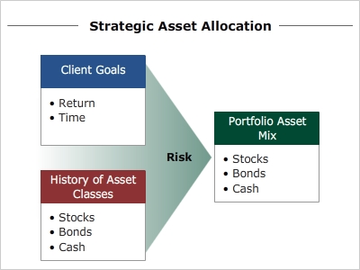

|  |
| --- |
| **Client Goals**  The strategic asset allocation process focuses on the client's goals and long-term perspective, as well as the rebalancing of the portfolio. Before generating a mix of assets within a portfolio, there must be an understanding of the goals and expectations of the client.  Being aware of such goals as the amount of risk willing to be taken, the amount of return desired and the time frame with which these goals can be reached, is essential in the strategic asset allocation process |

|  |
| --- |
| **History of Asset Classes**  The historical returns, volatility and future return expectations are the second primary inputs into a strategic asset allocation approach. The historical returns and volatility inputs are factual and cannot be debated.  However, the averages used here can be significantly different depending on the time period chosen to determine these data inputs. Be careful to utilize rational expectations and discuss the impact of a lower return environment. |

|  |
| --- |
| **Portfolio Asset Mix**  Taking into consideration the client's goals and the historical risk, return, and correlation of various asset classes, the strategic allocation process potential selects an asset allocation that is designed to meet the long-term objectives of the client. |

Because strategic asset allocation is based on client objectives, it must take into consideration the time horizons associated with these objectives.

|  |  |  |
| --- | --- | --- |
| |  |  | | --- | --- | | DocumentationIcon_32px | **Click the icon to view examples of client/prospect objectives and the time horizons typically associated with them.** | |
| |  |  | | --- | --- | | |  | | --- | | An investor may be saving for a new home, or education for children, the care of aging parents, or retirement.  Each of these objectives has a specific time frame associated with it, and assets need to be allocated to asset classes that provide the best risk/return relationship consistent with the time frame in question  37_time_horizon | | | |

## Tactical Asset Allocation

**Tactical asset allocation** has a more short-term focus, seeking to capitalize on short-term market conditions and anticipated market moves. This results in active shifting of the investments within a portfolio.

As the chart below shows, the combination of relative market valuations and the historical performance of asset classes are the primary considerations in determining the appropriate asset mix for a portfolio. Using a tactical method, the client’s goals and objectives are given less attention than the current market conditions and short-term market projections.

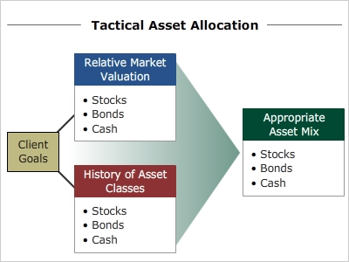

## Comparing Strategic vs. Tactical Allocation Strategies

In summary, tactical and strategic asset allocation can be compared by three basic factors, as illustrated in the chart below. Which approach an investment manager or firm takes may be an outgrowth of his or her stance regarding one or more of these factors.

**Strategic vs. Tactical Allocation Strategy Comparison**

|  |  |  |
| --- | --- | --- |
|  | **Strategic** | **Tactical** |
| **Time** | Long Term Oriented | Short Term Oriented |
| **Investment Activity** | Portfolio Rebalancing | More Trading Oriented |
| **Focus** | Client Goals | Market Projections |

## The Planning Process in Action

While every firm has its own approved approach to developing an effective asset allocation strategy for a client's portfolio, the following outline provides a list of the factors to consider in four primary steps to this process.

|  |
| --- |
| **Stage One – Assess the Situation**   * Quantify all client needs and objectives * Identify current assets * Define the time horizon * Understand the client’s risk tolerance (ability to handle short-term fluctuations in market value) * Define the specific liquidity needs and liquidity events * Assess the client’s tax situation (for each account as well as their overall tax status)   **Stage Two: Define Parameters**   * Define the appropriate asset classes to be considered for the client * Define the client’s deficit tolerances * Identify any deficit coverage assets that can be used to fund shortfalls in a scenario   **Stage Three: Optimize**   * Utilize Mean Variance Optimization to determine an effective portfolio mix * Use Monte Carlo sensitivity analysis to determine the probable “success rate” of an allocation in meeting the objective(s) within a client’s identified deficit tolerance   **Stage Four: Implement**   * Define a plan for rebalancing the portfolio * Establish parameters for re-optimization * Manage the allocation over time |

## Lack of Clearly Defined Objectives

One of the greatest difficulties in developing a good plan is identifying objectives. When asking many investors what their objectives are, they will tell you something like, “to save enough for my children’s college education” or “to live comfortably upon retirement.” While both are specific objectives, neither is specific enough to form the basis for effective planning. What must be identified is how much is required to meet the objective, what is the time horizon, what are the expected returns that can be achieved, what tax advantaged vehicles are available, and how much in annual or periodic funding can be added to the plan, etc. Without all of this specific information, no effective planning strategy can be developed.

As an advisor, you can add value by quantifying specific goals in terms of assets required to fund the obligation, isolating the tax-advantaged accounts they might be able to utilize, and calculating the probability of success using Monte Carlo Sensitivity Analysis.

Remember to always seek to understand the specific ways clients or prospects have already quantified their financial goals and obligations. Asking these simple questions can help you understand what they have done to date:

**How have you quantified your specific goals and future financial obligations?**

**How does your current plan identify the effectiveness of your plan in meeting your goals?**

Do not be concerned if they are unable to answer these questions effectively. Any inability to answer these questions simply increases their awareness of the need for specific plans and provides you with the opportunity to add value.

## Failure to Monitor/Manage the Portfolio Over Time

There are many different opinions on how often a portfolio allocation should be reviewed and optimized. Some say quarterly, others annually. The specific timeframe for revisiting and re-optimizing is not as important as actually doing it on a regularly scheduled basis.

Given the dynamic nature of the markets, and the ever-changing perspectives and needs of your clients, you are wise to schedule a review of the portfolio positions at least annually. And if the assets are in a trust account, an annual review is a requirement under Reg. 9.

|  |
| --- |
| **Reg. 9 Review**  This review should include the following information and perspective.   * Have there been any changes in the objectives of the client? * Have there been any changes in the risk tolerances of the client? * What are the current asset class weightings compared to the investment policy parameters set out in the plan? * What would be the transaction costs of re-balancing at this point? * Are there any tax considerations that need to be addressed or factored into the re-balancing? |

## Review Exercise

**Review the previous pages by answering the following questions.**

1. **Asset allocation is a process of diversification achieved by blending assets or asset classes.**

* True

**Correct.**

* False

**Incorrect.**

1. **Complete each statement by selecting the correct response from the pull down menus.**

**A**.  **\_\_\_\_\_\_\_\_\_\_ is short-term oriented.**

* Strategic Asset Allocation

**Incorrect**.

* **Tactical Asset Allocation**

**Correct.**

**B**.  **Investment activity using \_\_\_\_\_\_\_\_\_\_ is geared towards portfolio rebalancing.**

* **Strategic Asset Allocation**

**Correct.**

* Tactical Asset Allocation

**Incorrect**.

**C. \_\_\_\_\_\_\_\_\_\_ maintains a strong focus on market projections.**

* Strategic Asset Allocation

**Incorrect**.

* **Tactical Asset Allocation**

**Correct.**

**D. Investment activity using \_\_\_\_\_\_\_\_\_\_ is geared towards active trading based on market conditions.**

* Strategic Asset Allocation

**Incorrect**.

* **Tactical Asset Allocation**

**Correct.**

**E. \_\_\_\_\_\_\_\_\_\_ is long-term oriented.**

* **Strategic Asset Allocation**

**Correct.**

* Tactical Asset Allocation

**Incorrect**.

**F. \_\_\_\_\_\_\_\_\_\_ maintains a strong focus on client goals.**

* **Strategic Asset Allocation**

**Correct.**

* Tactical Asset Allocation

**Incorrect**.

## Conclusion

Most investors buy and sell securities on emotions. They tend to follow the pack, buying after most of the opportunity for gain is gone and selling after most of the decline has occurred. Such behavior is a recipe for poor performance, if not disaster.

You can offer a better approach. Using the knowledge you have gained from this course, you can offer a rational methodology that places emphasis on:

* Proper allocation instead of picking hot stocks.
* Diversification of risk
* Portfolios that are built around client needs, risk tolerances, and time horizons
* Testing portfolios to minimize outcome risk
* Ongoing monitoring and reallocation

The end result for the client is peace of mind – greater confidence in the expected results and lowers anxiety throughout the process.

Apply yourself to not only master the techniques of proper asset allocation, but to also master your ability to communicate the techniques and their advantages to clients. By helping them to become more knowledgeable themselves, they will have higher confidence in the role you play and place greater value in the services you provide.